LAB Logbook

Lab 1

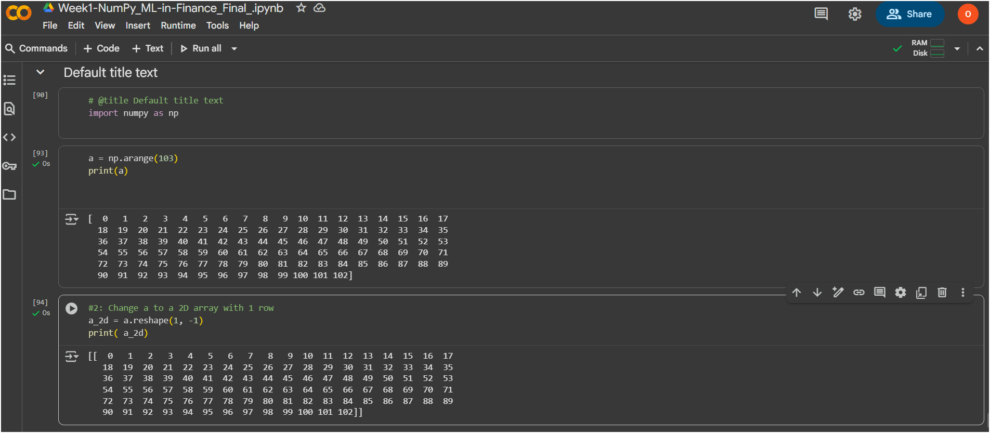

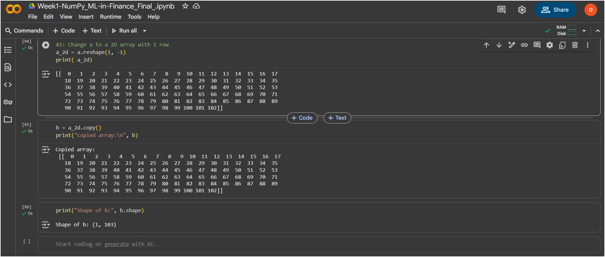

Lab 2

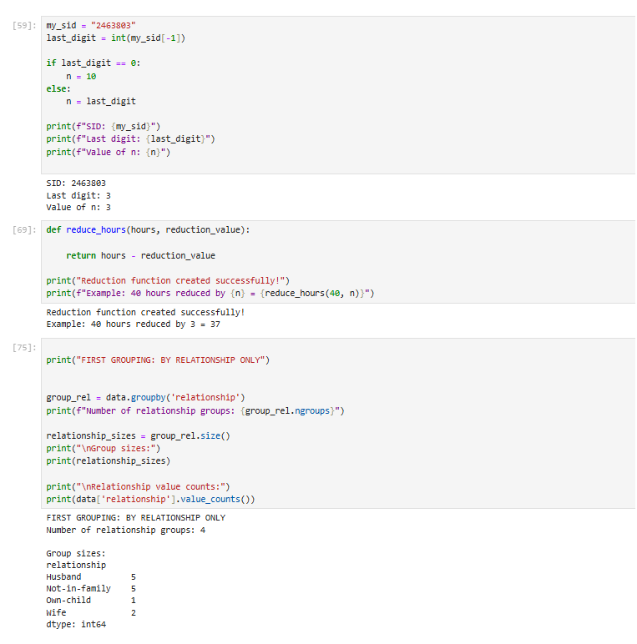

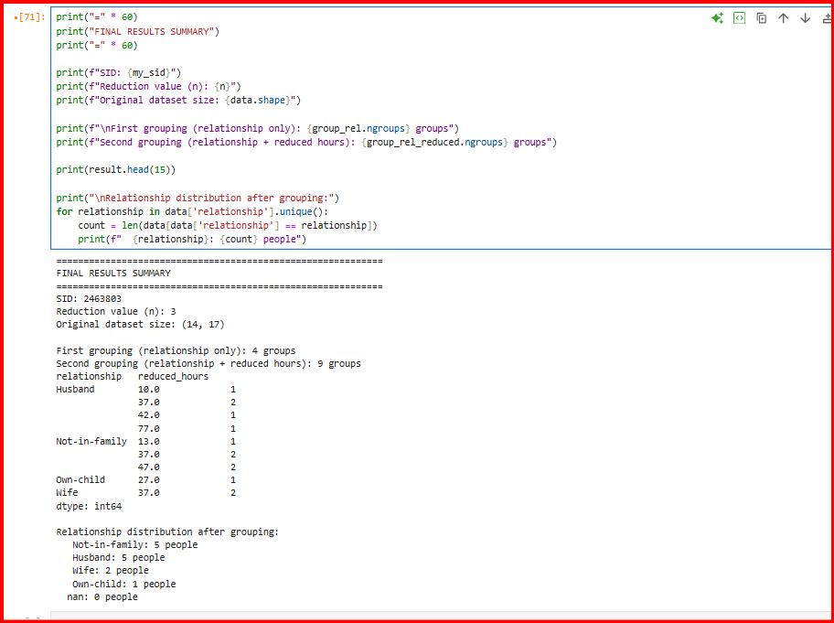

Lab 3

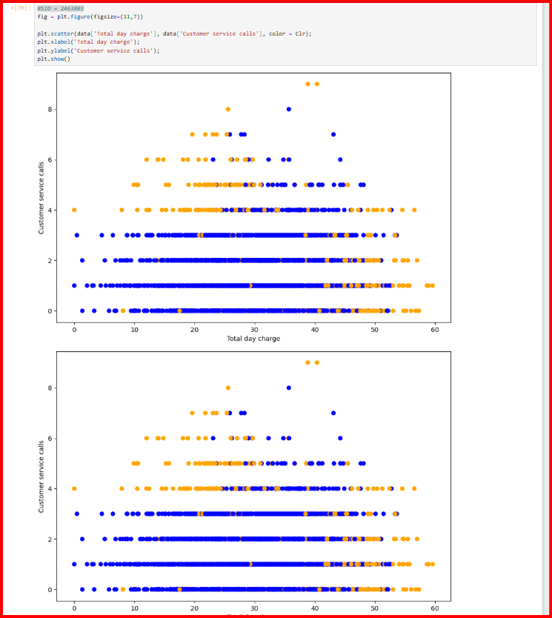

Lab 4

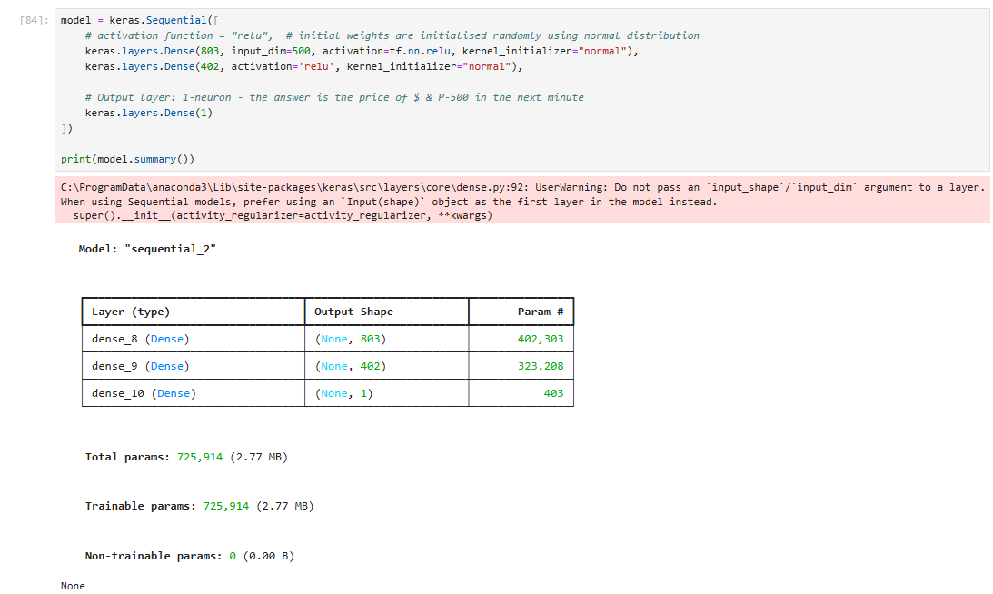MLP architecture

MLP Training Code and process

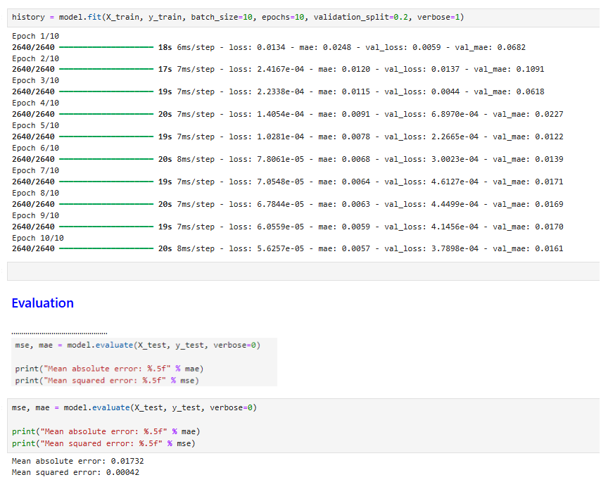

Resulting MAE on the test data



Lab 5

Lab 6

Lab 7

Lab 8

Lab 9

Lab 10

Lab 11

Lab 12